SIMATS ENGINEERING
ASSESSMENT TOOL 2: Industry Problem Solving Task

COURSE NAME: | Cloud Computing and  Big Data Analytics | COURSE CODE: | CSA1508

COURSE OUTCOME COVERED
CO4: Analyze big data characteristics and challenges across domains including security and application aspects.
(BL4)

Dave's Taxonomy: Articulation (Level 4)  Question Count: 5 | Total Marks: 40

Code of Conduct
I P.Muni Lokesh(192372181)(Name / Reg. No.) certify that this submission is my original work and that I have adhered to the guidelines specified for this assessment. I understand that any violation of academic integrity rules will result in disciplinary action.
Signature of the student: P.Muni Lokesh

Assessment Tasks
Industry Problem Solving Task
- Retail Data Optimization Problem - A retail chain operates both physical stores and an online platform. It generates large volumes of sales, inventory, and customer behavior data. The company wants real-time inventory tracking and demand forecasting. It also aims to deliver personalized marketing recommendations to customers. Design a big data architecture to support these requirements. Explain the tools, technologies, and analytics models you would use.
Answer:
Industry Context
A hybrid physical-and-online retailer sits at the intersection of three demanding requirements: inventory has to be accurate within minutes across every store and warehouse, demand has to be forecast well enough to avoid both stockouts and overstock, and marketing has to feel personal to each shopper rather than generic. Any architecture proposed has to satisfy real-time operational needs (inventory) and slower, deeper analytical needs (forecasting, personalization) at the same time, which is why a mixed batch-and-stream design is appropriate rather than a single processing path.
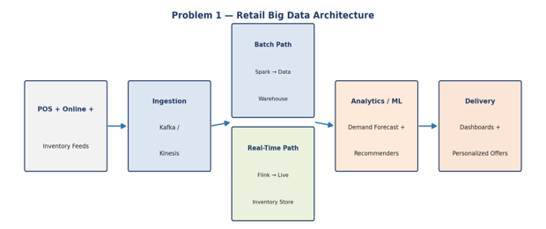
Proposed Architecture
- Ingestion: Point-of-sale terminals, the e-commerce platform, and warehouse management systems publish events (sales, stock movements, browsing/cart activity) to Apache Kafka, which decouples fast-moving source systems from downstream consumers and allows multiple teams to consume the same event stream independently.
- Real-time inventory path: A stream processor (Apache Flink or Spark Structured Streaming) consumes stock-movement events and updates a low-latency store (Redis or Apache Cassandra) that powers store associate apps and the website's "in stock" indicators, so inventory counts reflect reality within seconds rather than at end-of-day batch refresh.
- Batch analytical path: The same Kafka topics are also archived into a data lake (S3/HDFS in Parquet format) and periodically processed by Spark into a data warehouse (Snowflake/BigQuery) that holds historical sales, seasonality, and promotion data for deeper analysis.
- Demand forecasting: A time-series forecasting model (Facebook Prophet, ARIMA, or a gradient-boosted model such as XGBoost with engineered lag features) is trained on the warehouse data per SKU/store combination, retrained on a scheduled cadence (e.g., nightly) via an orchestrator like Apache Airflow.
- Personalized recommendations: A collaborative-filtering or embedding-based recommendation model (Spark MLlib ALS, or a two-tower deep learning model) trained on purchase and browsing history generates per-customer product affinities, served through a low-latency feature store so recommendations can be shown during a live browsing session.
Analytics Models and Tooling Summary
- Inventory: stream aggregation + threshold-based reorder alerts
- Forecasting: time-series regression (Prophet/ARIMA) or gradient boosting with holiday/promotion features
- Personalization: collaborative filtering / embedding similarity, re-ranked by business rules (margin, inventory availability)
- Delivery: BI dashboards (Power BI/Tableau) for planners; an API-served recommendation widget for the website and app
Security and Operational Risk Awareness
- Data privacy: customer purchase history and browsing behavior are personally identifiable; access to the raw event stream should be role-restricted, and marketing models should ideally train on pseudonymized customer IDs rather than raw PII.
- Model risk: an inaccurate demand forecast can cause costly overstock or stockouts, so forecasts should ship with confidence intervals and be reviewed by planners rather than fully automating reorder decisions for high-value SKUs.
- System resilience: the real-time inventory path is business-critical (a wrong "in stock" flag directly loses sales), so the streaming layer should be deployed with replication and automatic failover rather than a single point of failure.

- Social Media Fraud Detection Problem - A social media platform processes billions of user interactions daily. These include posts, comments, likes, and shares. The platform wants to detect fake accounts and misinformation quickly. Real-time or near real-time processing is required. Design a scalable big data solution for this use case. Explain the role of machine learning and stream processing frameworks.
Answer:
Industry Context
At the scale of billions of daily interactions, manual or purely rule-based moderation cannot keep pace, and the reputational and regulatory cost of slow detection (viral misinformation, fake-account-driven manipulation) is high. The core engineering challenge is achieving near-real-time classification over an extremely high-throughput, noisy, adversarial stream, where bad actors actively try to evade detection — this pushes the design toward scalable stream processing paired with continuously retrained machine learning rather than static rules alone.
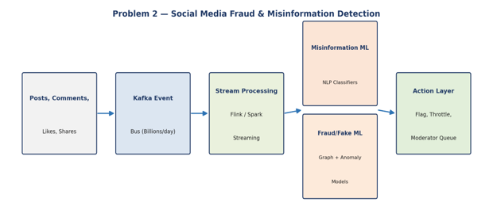
Proposed Architecture
- Ingestion: All user actions (posts, comments, likes, shares, account-creation events, login patterns) are published to a high-throughput distributed log (Kafka), partitioned by user or content ID to allow parallel consumption at scale.
- Stream processing: Apache Flink or Spark Structured Streaming continuously computes behavioral features in sliding windows — posting frequency, network-graph velocity (how fast a new account accumulates connections), content similarity to known misinformation, and engagement anomalies — since fraud and coordinated inauthentic behavior show up as pattern deviations over short time windows.
- Fake-account detection: A graph-based approach (e.g., using a graph database like Neo4j or GraphFrames on Spark) identifies clusters of accounts with suspicious interconnection patterns (bot rings, coordinated like/share farms), supplemented by supervised anomaly-detection models (e.g., Isolation Forest or gradient-boosted classifiers) trained on account-age, activity-velocity, and device-fingerprint features.
- Misinformation detection: NLP classifiers (fine-tuned transformer models such as BERT-family models, or simpler TF-IDF + gradient boosting for lower latency) score post/comment text and compare against a continuously updated database of known false claims, with a human fact-checking review queue for borderline or high-impact content.
- Action layer: Content or accounts crossing a confidence threshold are automatically throttled (reduced distribution) or queued for human moderator review, rather than being auto-deleted outright, balancing speed with the risk of wrongly silencing legitimate users.
Role of Machine Learning and Stream Processing
Stream processing is what makes near-real-time detection possible at this volume — it computes rolling behavioral features without needing to re-scan historical data for every new event, keeping latency low. Machine learning is applied in two complementary modes: supervised models trained on confirmed past fraud/misinformation cases classify new content and accounts against learned patterns, while unsupervised/graph-based anomaly detection catches novel attack patterns that have not been seen before, which matters because malicious actors continuously adapt their tactics to evade known-pattern detection.
Security and Operational Risk Awareness
- Adversarial evasion: detection models must be retrained frequently since bad actors adapt quickly once they learn what triggers flags; a static model will degrade in effectiveness over time.
- False positives and free-expression risk: aggressive automated takedowns risk silencing legitimate users, so a human-in-the-loop review step for high-impact or borderline decisions is an important safeguard, along with an appeals mechanism.
- Data governance: user interaction data used for training models is sensitive; access should be limited to the trust-and-safety team, and models should avoid using protected characteristics (e.g., inferred ethnicity or political affiliation) as direct features to reduce discriminatory bias.

- Government Data Platform Problem A government agency is building a national data platform. It combines census, economic, and geospatial datasets. Different departments need access to shared and integrated data. The system must ensure interoperability across multiple agencies. Strict privacy and security requirements must be followed. Propose a governance and data management strategy.
Answer:
Industry Context
Government data platforms differ from most commercial big data systems in one crucial respect: the primary challenge is organizational and governance-related as much as technical. Multiple independent agencies, each with their own legacy systems, data formats, and legal mandates, must share data without duplicating effort, while strict privacy law (e.g., census confidentiality requirements) and security obligations constrain who can see what. The proposed strategy therefore centers on governance and interoperability at least as much as on the storage/processing stack.
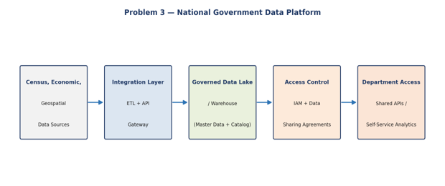
Proposed Architecture and Governance Strategy
- Integration layer: An ETL/ELT layer (Apache NiFi or a managed data-integration service) ingests data from each agency's source systems, applying standardized schemas and identifiers (e.g., common geographic codes, standardized entity IDs) so census, economic, and geospatial data can be joined meaningfully across sources.
- Interoperability standards: Open, well-documented data standards (e.g., statistical data exchange formats like SDMX for economic data, and OGC standards for geospatial data) are adopted so that department-specific tools can consume shared data without custom point-to-point integrations.
- Governed data lake/warehouse: A central repository stores integrated datasets with a data catalog (e.g., a metadata catalog service) documenting lineage, ownership, and sensitivity classification for every dataset, which is essential when many departments need to know what data exists and whether they are authorized to use it.
- Data governance body: A cross-agency data governance committee likely defines data-sharing agreements, approves new integrations, and sets retention and classification policy, since technical access control alone cannot resolve legal or jurisdictional questions about who owns or may use a given dataset.
- Access model: Role-based and attribute-based access control (RBAC/ABAC) tied to each department's legal mandate, combined with a self-service API layer so departments query only the data they are authorized for, rather than receiving unrestricted database access.
Privacy and Security Requirements
- Statistical disclosure control: for census-derived data, techniques like data aggregation, k-anonymity, or differential privacy should be applied before sharing to prevent re-identification of individuals from combined datasets — a well-known risk when multiple "anonymized" datasets are joined together.
- Encryption and audit: data should be encrypted at rest and in transit, and every cross-department access should be logged immutably, supporting compliance audits and public accountability.
- Least-privilege access: departments should receive the minimum data granularity needed for their function (e.g., aggregated regional statistics rather than individual records) unless a specific, approved legal basis exists for finer-grained access.
- Data residency and sovereignty: given the national scope, the platform should keep data within legally mandated jurisdictional boundaries, which likely rules out certain public cloud regions depending on the country's data-residency laws.

- Banking Fraud Detection Problem
A bank processes millions of financial transactions every minute. It needs to detect fraudulent activities in real time. The system must analyze historical and streaming transaction data.
Low latency and high accuracy are critical requirements. Design a big data pipeline for fraud detection. Explain the technologies and algorithms you would implement.
Answer:
Industry Context
Banking fraud detection is one of the most latency-sensitive big data problems in industry: a fraudulent transaction ideally must be scored and potentially blocked within the same authorization request, typically under 100-200 milliseconds, while still weighing the transaction against a rich history of the customer's past behavior. This dual requirement — sub-second response time plus deep historical context — is the central design tension the architecture must resolve.
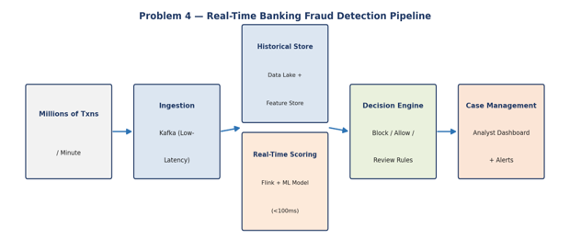
Proposed Pipeline
- Ingestion: Transaction events stream through a low-latency, high-throughput message bus (Kafka, tuned for minimal partition lag) as they are authorized, since batch ingestion would be far too slow for a real-time blocking decision.
- Real-time scoring: A stream processor (Apache Flink, chosen over Spark Streaming in latency-critical deployments for its lower event-at-a-time processing latency) evaluates each transaction against a pre-trained fraud model within the authorization window, pulling recent behavioral features (e.g., spending velocity in the last hour) from a low-latency feature store (Redis) rather than querying a data warehouse live.
- Historical context: A data lake and warehouse store years of transaction history used both for offline model training and for computing longer-term behavioral baselines (e.g., "average monthly spend") that are periodically refreshed into the feature store rather than computed on the fly.
- Model choice: Gradient-boosted tree models (XGBoost/LightGBM) are commonly favored in production fraud systems for their strong accuracy on tabular data and fast inference; graph-based models can supplement this by detecting rings of connected fraudulent accounts/merchants, and unsupervised anomaly detection (autoencoders, Isolation Forest) helps catch entirely new fraud patterns not present in labeled training data.
- Decision engine: Transactions scored above a high-confidence fraud threshold are auto-blocked; those in a middle-confidence band are routed to step-up authentication (e.g., an SMS/app confirmation) rather than outright blocked, balancing fraud prevention against customer friction and false positives.
- Case management: Flagged transactions and model rationale (e.g., top contributing features) are surfaced to a fraud-analyst dashboard for investigation and to provide labeled feedback that improves future model retraining.
Latency and Accuracy Trade-offs
Achieving both low latency and high accuracy typically requires a tiered approach: a fast, lightweight model (or rule set) makes the initial real-time decision within the authorization window, while a more complex model or graph analysis runs asynchronously afterward to catch fraud that the real-time layer missed, feeding results into post-transaction alerts, chargebacks, and future model improvement — accepting that not every fraud case can be caught before the transaction completes.
Security and Operational Risk Awareness
- Model drift: fraud patterns evolve quickly (fraudsters adapt to known detection rules), so models require frequent retraining and continuous monitoring of false-positive/false-negative rates rather than a "train once" approach.
- Explainability: regulators typically require banks to explain why a transaction was blocked or a customer was denied, which favors model choices (or supplementary explanation tools like SHAP) that support interpretable feature attribution over pure black-box models.
- System availability: the fraud-scoring service sits in the critical path of every transaction, so it needs a fail-safe design (e.g., defaulting to a conservative rule-based fallback if the ML service is unreachable) rather than blocking all transactions during an outage.
- Data security: financial transaction data is highly regulated (PCI-DSS); sensitive fields (card numbers) should be tokenized before entering the analytics pipeline so raw card data never needs to be exposed to the fraud-scoring or analytics layers.

- Agriculture Smart Farming Problem

A smart farming system collects soil, weather, and crop data. Sensors and drones provide real-time field information. Farmers want insights to improve yield and resource usage. Data is generated from multiple distributed sources. Design a big data solution for precision agriculture. Explain how analytics can support decision-making.
Answer:
Industry Context
Smart farming data originates from many physically distributed, often remote and connectivity-limited sources (field sensors, drones) rather than centralized digital systems, and decisions (irrigation timing, fertilizer application) are time-sensitive but not typically sub-second — insight delivered within hours is usually sufficient, unlike banking fraud or social media moderation. This relaxes the latency requirement compared to the earlier problems, but introduces its own challenge: unreliable rural connectivity and the need to fuse very different data types (continuous sensor time-series, periodic drone imagery, geospatial field boundaries) into decision-ready insight.

Proposed Architecture
- Edge layer: Field sensors (soil moisture, temperature, humidity) and drones feed a local edge gateway that performs initial filtering and compression, since rural connectivity is often intermittent or bandwidth-limited and transmitting every raw reading continuously is impractical.
- Messaging: A lightweight IoT protocol (MQTT) is likely used between sensors/gateways and the cloud given its low overhead and built-in support for unreliable networks (quality-of-service delivery guarantees, offline buffering), with Kafka as the backbone once data reaches more reliable infrastructure.
- Storage: Continuous sensor readings are stored in a time-series database (InfluxDB/TimescaleDB) optimized for high-write-volume, time-indexed data, while drone imagery and field-boundary data are stored with geospatial indexing (PostGIS or a geospatial-enabled data lake) to support location-based queries (e.g., "which zones of this field are under-irrigated").
- Analytics and ML: Yield-prediction models (regression or gradient boosting trained on historical yield, weather, and soil data) forecast expected output per field zone; computer-vision models applied to drone/satellite imagery detect crop stress, pest damage, or irrigation gaps by analyzing spectral indices (e.g., NDVI); and rule-based or ML-driven irrigation recommendation engines combine soil-moisture readings with weather forecasts to suggest watering schedules.
- Delivery: Insights are delivered through a simple mobile app dashboard designed for field use (offline-capable, low-bandwidth friendly) rather than a desktop BI tool, given that farmers often need to check recommendations while physically in the field with limited connectivity.
How Analytics Supports Farmer Decision-Making
Rather than presenting raw sensor charts, the analytics layer should translate data into direct action recommendations — for example, converting soil-moisture and weather-forecast data into a specific "irrigate zone 3 for 20 minutes tomorrow morning" instruction, and converting NDVI drone imagery anomalies into a mapped alert showing exactly which rows of a field need inspection. This task-oriented framing is what turns a big data pipeline into a genuinely useful precision-agriculture tool, since most farmers are agronomy experts but not data analysts.
Security and Operational Risk Awareness
- Connectivity resilience: edge gateways should buffer data locally and sync when connectivity resumes, since rural network outages should not cause silent data loss.
- Device security: field sensors and drones should authenticate via certificates or signed tokens to prevent spoofed readings from manipulating irrigation or fertilizer decisions, which could otherwise cause real crop damage.
- Data ownership: farm-level data (yield, field performance) is commercially sensitive to the farmer; platform providers should be transparent about data ownership and avoid using an individual farm's proprietary data to benefit competitors without consent.
Model reliability: yield predictions and pest-detection alerts should communicate confidence levels, since an over-confident wrong recommendation (e.g., under-watering during a dry spell) has direct, costly real-world consequences for the farmer.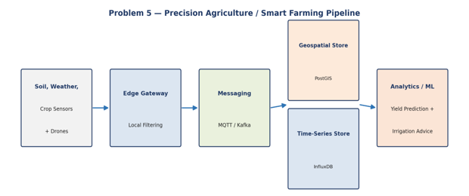
Industry Problem Solving Rubric

Criteria | Weightage | Level 4 - Exemplary | Level 3 - Proficient | Level 2 - Developing | Level 1 - Beginning | Total Marks
Understanding of Industry Context | 20% | Demonstrates strong understanding of real-world problem  context | Good understanding | Basic understanding | Weak understanding
Application of Big Data  Concepts | 25% | Applies highly relevant big data  ideas and tools | Mostly appropriate  application | Partial application | Weak application
Solution Design | 25% | Solution is practical,  scalable, and well-reasoned | Reasonable solution | Basic solution with gaps | Unclear solution
Security / Risk Awareness | 15% | Strong awareness of security and  operational risks | Reasonable awareness | Limited awareness | Poor awareness
Clarity and  Professionalism | 15% | Well-structured and  professional response | Generally clear | Moderately  clear | Poorly  presented

Total Marks Awarded:

